Target 9842 7764
Longest Covered Bridge in the world, Hartland, Canada

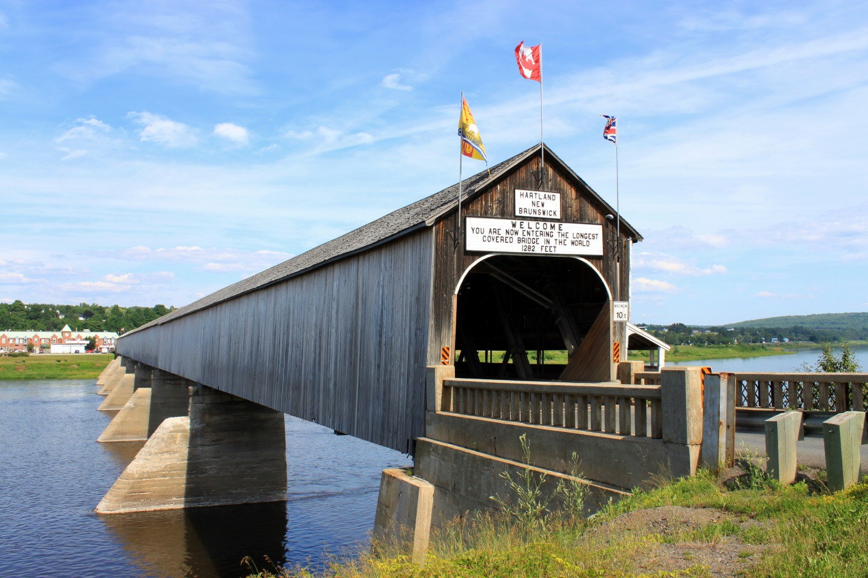

Fair Use For Teaching. Image purchased from Dreamstime.
http://www.dreamstime.com/royalty-free-stock-photo-longest-covered-bridge-world-image15218935

