Target 7591 6872
Lake Nong Harn, Thailand
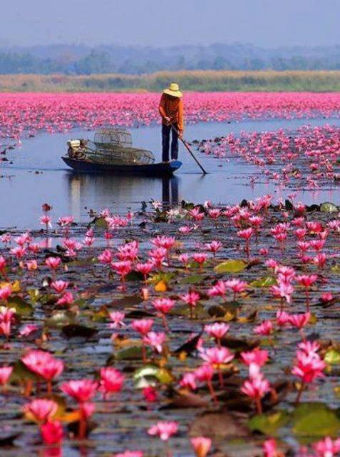

Fair Use For Teaching. Image retrieved from the Internet 6/24/13

