Target 5501 9700
Tiger Ice Sculpture

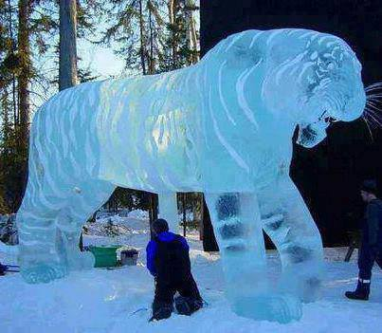

Fair Use For Teaching. Retrieved 6/25/13.

