Target 4319 8724
Aquaduct Veluwemeer, Netherlands

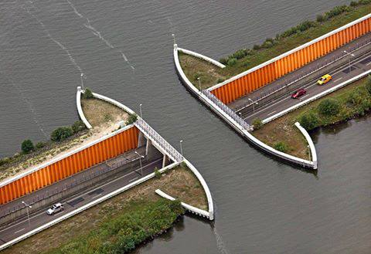

Fair Use For Teaching. Retrieved 6/25/13.
http://alk3r.files.wordpress.com/2013/06/aquaduct-veluwemeercebfcebbcebbceb1cebdceb4ceafceb1.jpg

