Target 2876 4838
Victoria Falls, Zimbabwe

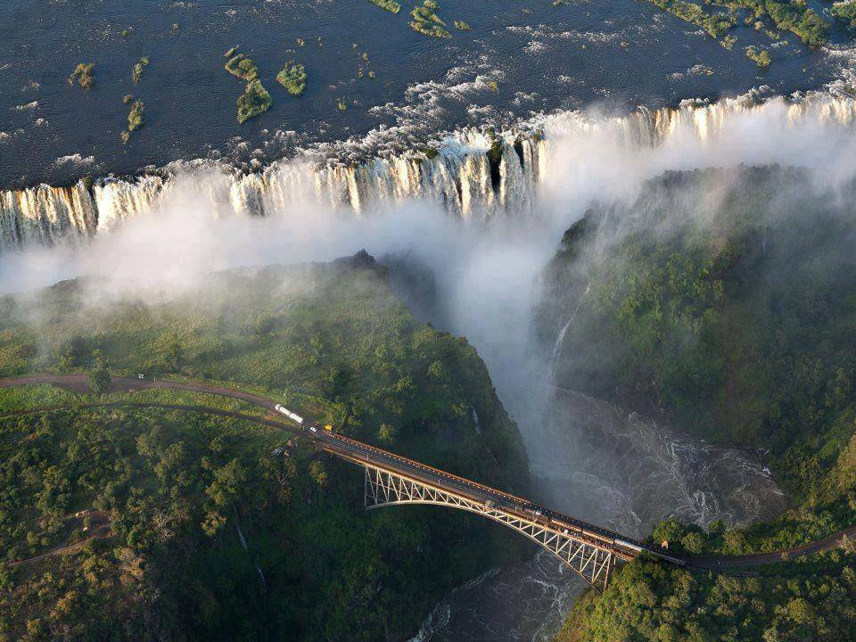

Fair Use For Teaching. Retrieved 6/25/13.
http://www.travelstart.co.za/blog/wp-content/uploads/2012/08/Vic-Falls-Zimbabwe.jpg

