Target 2656 1069
Very Large Array, Socorro, New Mexico

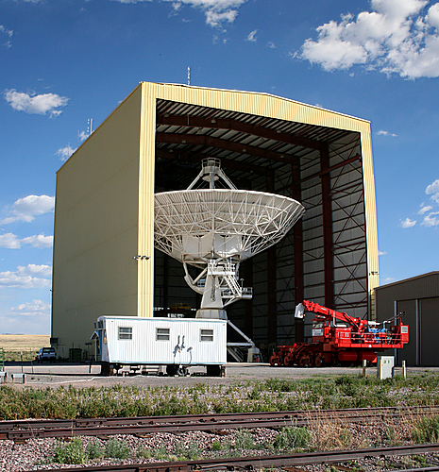

Fair Use For Teaching. Image retrieved 7/5/13.
http://www.panoramio.com/photo/3107273

