Target 2581 5009
Outdoorsman, Breckenridge, Colorado

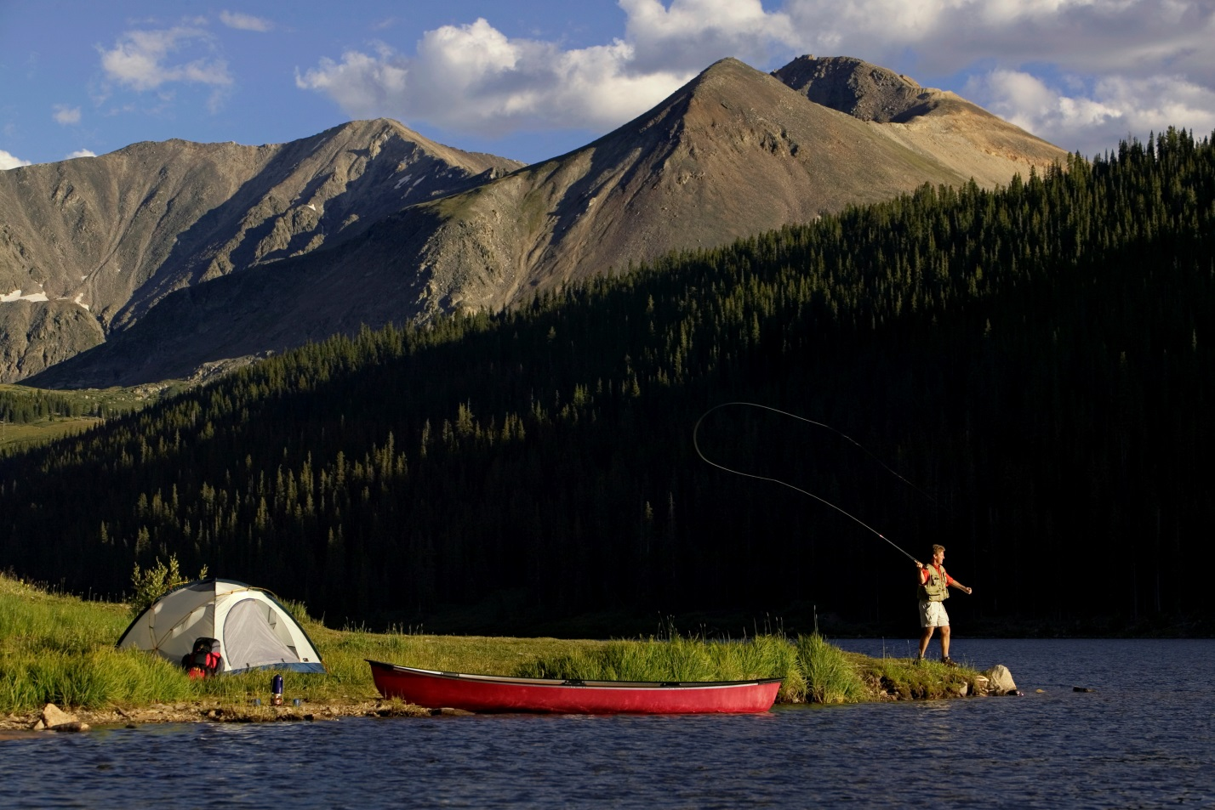

Fair Use For Teaching. Image retrieved 7/5/13.
http://www.google.com/search?q=colorado+canoeing&hl=en&source=lnms&tbm=isch&sa=X&ei=X1HXUbCyJOTYyQGL0IHoAg&ved=0CAkQ_AUoAQ&biw=1313&bih=674#facrc=_&imgrc=swvbNmdeSLVG1M%3A%3BjyQ8FjP7gQAAyM%3Bhttp%253A%252F%252Fcdn.allsummitcounty.com%252Fimages%252Fcontent%252F5846_7117_Breckenridge_Colorado_Canoeing_md.jpg%3Bhttp%253A%252F%252Fwww.allsummitcounty.com%252Fsummer_recreation%252Fcanoe_kayak.php%3B500%3B300

