Target 9846 8252
Banpo Bridge World’s Longest Bridge Fountain - South Korea

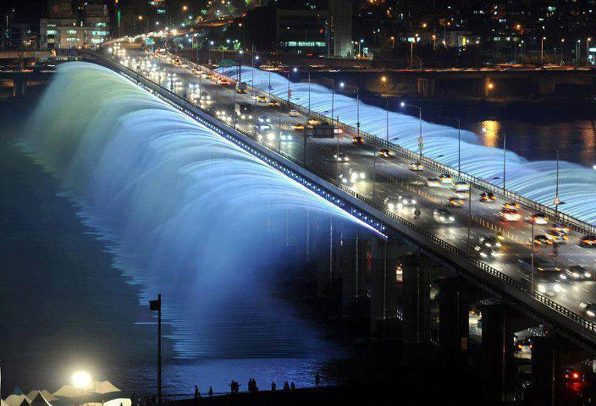

Fair Use For Teaching. Retrieved 6/25/13.
http://humorgemsup.blogspot.com/2013/06/worlds-longest-bridge-fountain-banpo.html

