Target 9750 6648
SVAM International Ice Art Exhibit

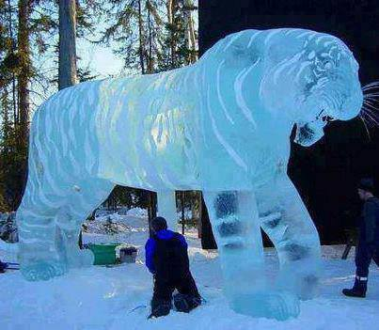

Fair Use For Teaching. Retrieved 6/25/13.
http://svam.org/gallery/006/images/brice_brown/bricebrown_tiger_stan04.jpg

