Target 9741 8851
Hopetoun Falls

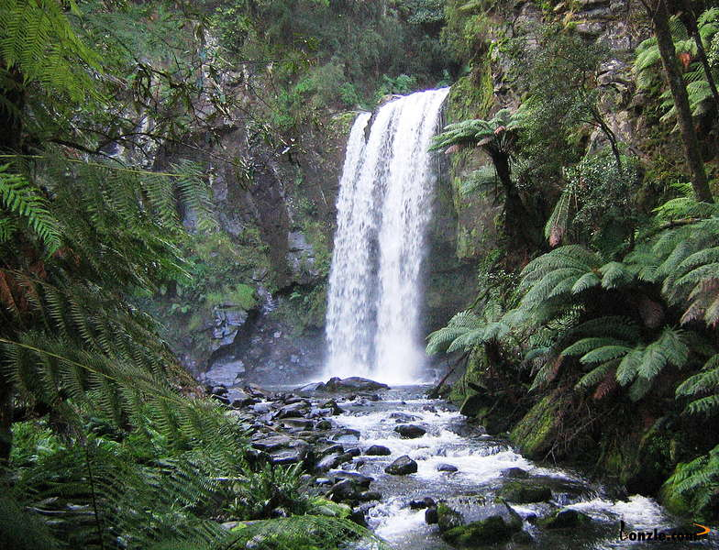

Fair Use For Teaching: image retrieved 6/25/13. http://www.bonzle.com/c/a?a=p&p=252866&cmd=sp

