Target 9384 8749
The Black Knight Satellite
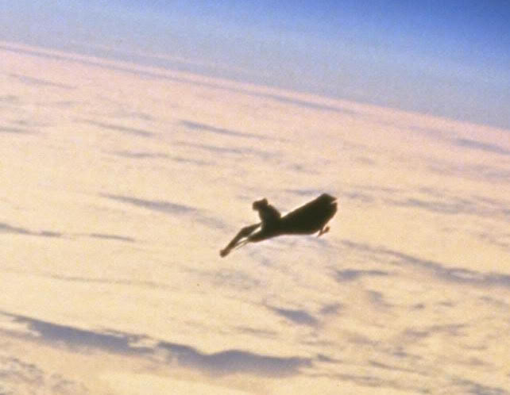

Space Junk or Extraterrestrial “Satellite”, the “Black Knight” as it’s called today– has been around for quite some time now. This discovery is perhaps one of the most (in)famous space objects that orbit our Planet. This “Artificial Satellite” has caused mayor media interest since the late 50′s, and it has become one of the most talked about objects in space. First thought to be an Russian spy satellite, the Black Knight has gripped the interest of millions worldwide. According to monitoring agencies around the world, The Black knight has been transmitting radio signals for over 50 years now. The USA and Soviet Union have shown particular interest in this “unidentified space object”. Since its discovery this satellite has interested countries such as Sweden and enthusiasts worldwide. One of them is a Ham Radio operator who apparently had decoded a series of signals received from the UFO Satellite and interpreted it as a star-chart centered on the Epsilon Bootes Star System and that the Black Knight originated from this System 13.000 years ago. (The Epsilon Boötis is a double star in the northern constellation of Boötes. It has the traditional names Izar and Pulcherrima. The star system can be viewed with the unaided eye at night, but resolving the pair with a small telescope is challenging; an aperture of 76 mm (3.0 in) or greater is required. — Wikipedia) But according to many, this discovery was made much earlier than we thought. Rumors are that it was Nikola Tesla the first man to “intercept” a signal from this otherworldly satellite in 1899 after building a high-voltage radio device in Colorado Springs. After Tesla’s discovery in the next 30 to 50 years the signal was being intercepted more frequently until it was apparently “decoded”. Since the 1930′s Astronomers worldwide have been reporting strange radio signals which allegedly come from the “Black Knight”. In 1957, Dr. Luis Corralos of the Communications Ministry in Venezuela photographed it while taking pictures of Sputnik II as it passed over Caracas. The strange thing was that unlike the Sputnik one and two, The Black Knight Satellite orbited Earth from East to West. Sputnik one and two orbited West to East using Earth’s natural rotation to maintain orbit. The story of the Black Knight made its media debut in the 1940′s when the St. Louis Dispatch and The San Francisco Examiner wrote about the “Satellite” on May 14th 1954. The Time Magazine wrote about it on the seventh of March, 1960. Here is what they said about it. - See more at: http://www.ancient-code.com/the-black-knight-a-13000-year-old-alien-satellite/#sthash.ktxpTl6p.dpuf

Fair Use For Teaching. Retrieved 7/1/13.
http://www.ancient-code.com/the-black-knight-a-13000-year-old-alien-satellite/#
Close-up image. Image credit NASA. - See more at: http://www.ancient-code.com/the-black-knight-a-13000-year-old-alien-satellite/#sthash.ktxpTl6p.dpuf

