Target 9211 6128
Skywalking, Mt. Nimbus, Canada

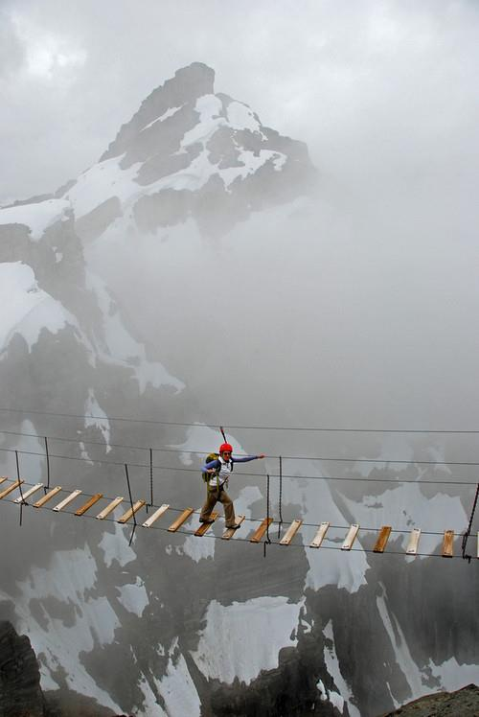
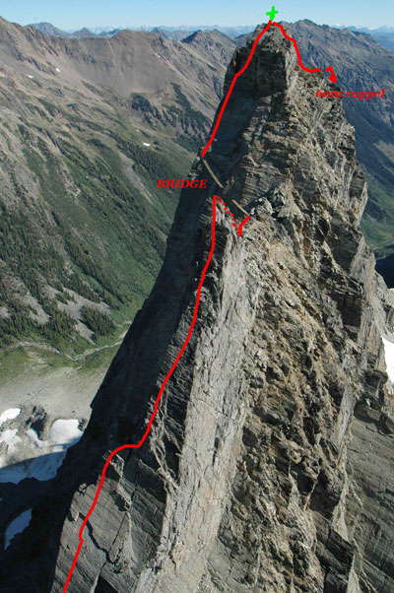
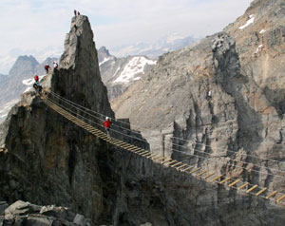
Fair Use For Teaching:
Image #1 retrieved 7/5/13. http://www.google.com/search?q=sky+walking+mt+nimbus+canada&sa=X&hl=en&tbm=isch&tbo=u&source=univ&ei=p0bXUdW7C-SMyAGwjIGQDA&ved=0CCwQsAQ&biw=1313&bih=674#facrc=_&imgdii=_&imgrc=1q7LgC2dXQ1svM%3A%3BUDv6QtNDgPT4zM%3Bhttp%253A%252F%252Fpbs.twimg.com%252Fmedia%252FBHotb4DCUAAjS8J.jpg%253Alarge%3Bhttp%253A%252F%252Ftwicsy.com%252Fi%252FgmCNxd%3B403%3B403
Images #2 and #3 retrieved 7/5/13.
http://www.canadianmountainholidays.com/heli-hiking/faq/via-ferrata

