Target 7296 5067
Climbing A High Mountain

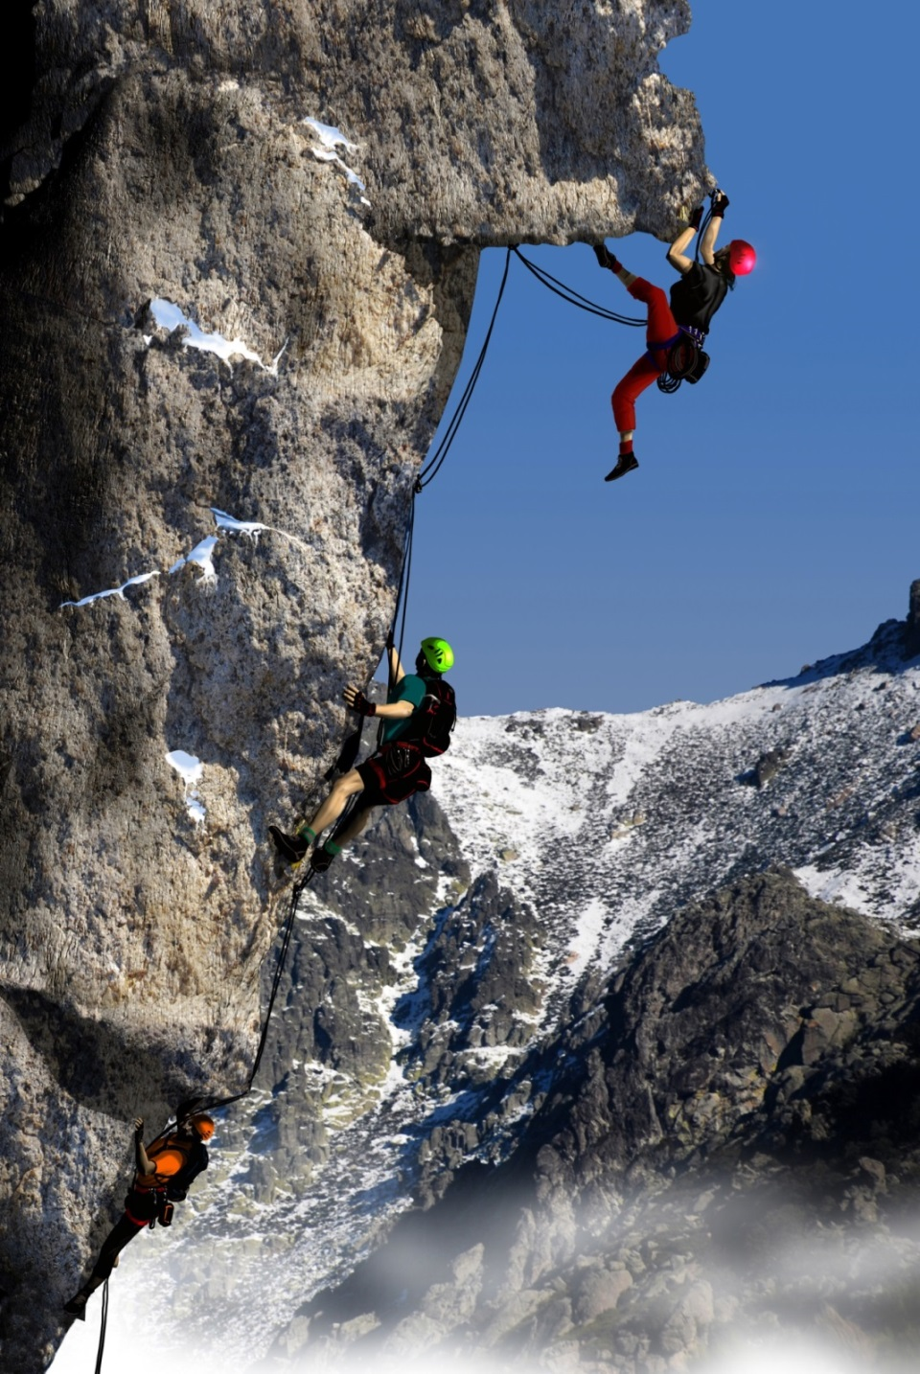

Fair Use For Teaching. Image purchased from Dreamstime.
http://www.dreamstime.com/royalty-free-stock-photography-climbing-high-mountain-image18406607

