Target 5512 9346
Temple Elephant, Thanjavur, India

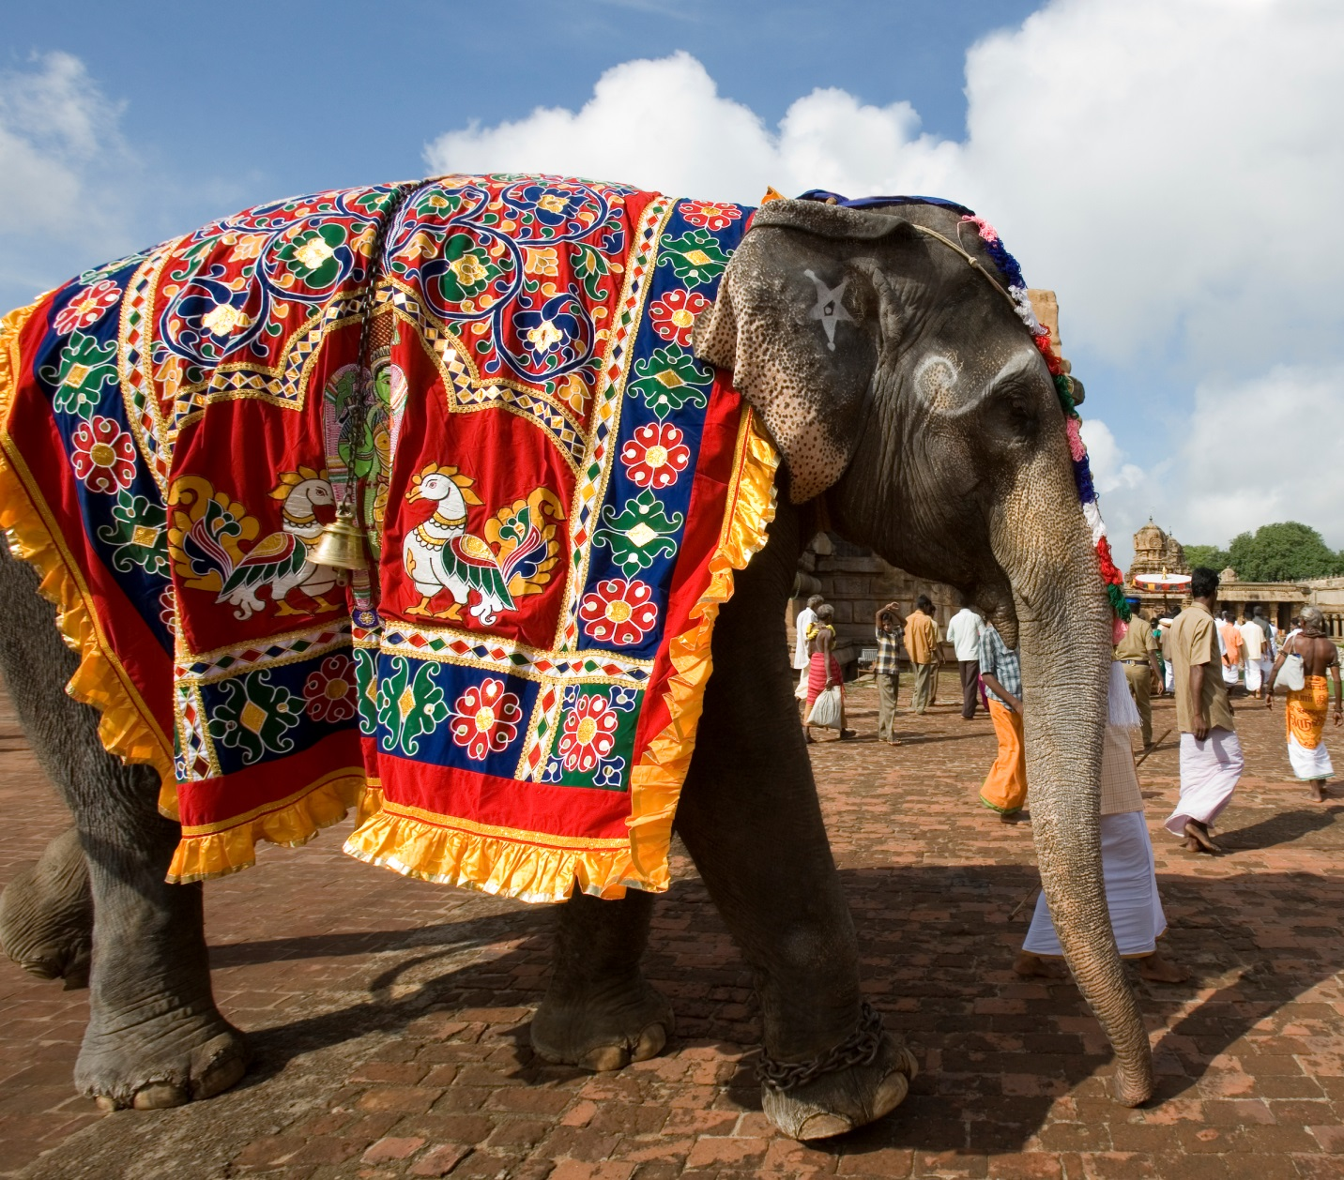

Fair Use For Teaching. Image purchased from Dreamstime.
http://www.dreamstime.com/stock-images-temple-elephant-thanjavur-india-image19196354

