Target 4895 5336
Taxiway Bridge at Changi Airport, Singapore

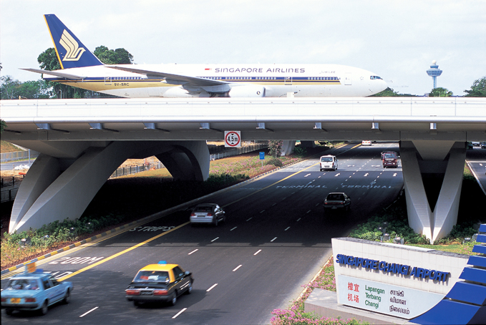

Fair Use For Teaching. Retrieved 6/25/13.
http://www.cpgcorp.com.sg/CPGC/Content/Projects/1132/1132_03.jpg

