Target 4630 2731
The Wedding Cake

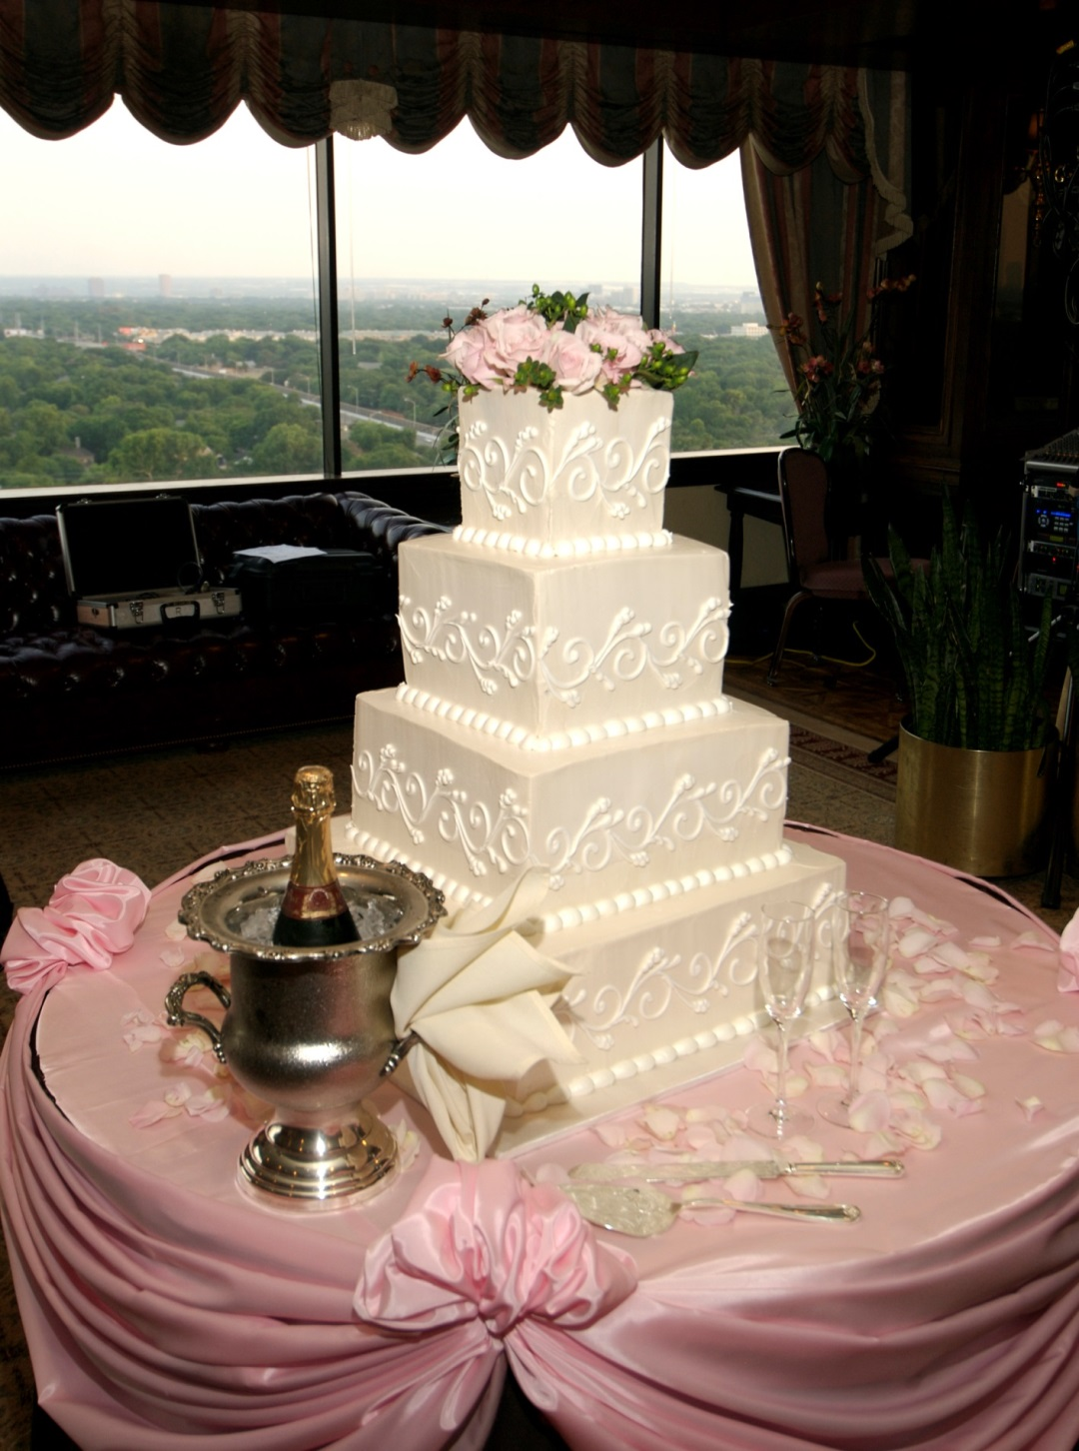

Fair Use For Teaching. Image retrieved 7/5/13.
http://www.pettysfinefoods.com/images/08_catering_wedding_cake_500.jpg

