Target 3650 6476
Aerial View of the Seven Mile Bridge, Florida Keys

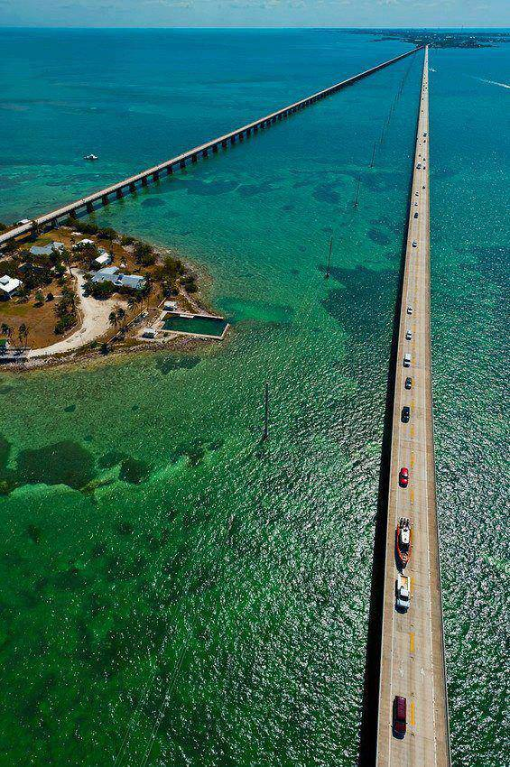

Fair Use For Teaching. Retrieved 6/24/13.

