Target 3442 7967
Male Ruby-Throated Hummingbird In Flight

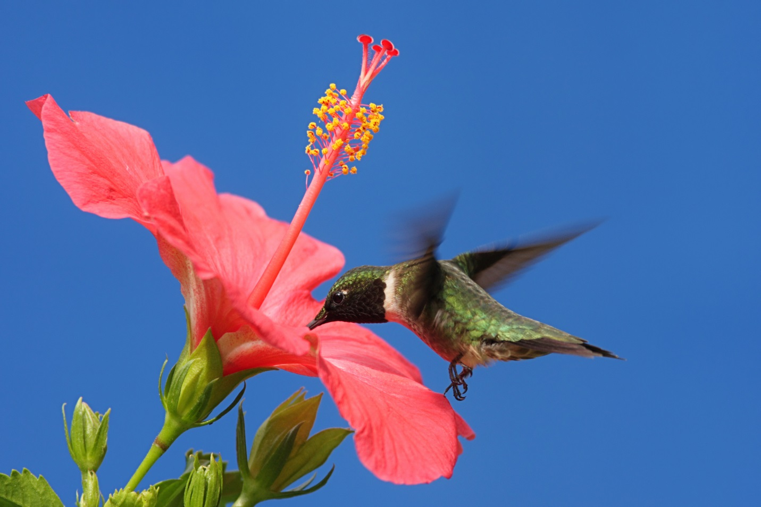
What does a hummingbird do? Feeds and pollinates.

Fair Use For Teaching. Image purchased from Shutterstock.
http://www.shutterstock.com/pic-61559266/stock-photo-male-ruby-throated-hummingbird-archilochus-colubris-in-flight-with-a-hibiscus-flower-and-a-blue.html

