Target 3219 1114
Vanishing Underwater Roller Coaster in Japan
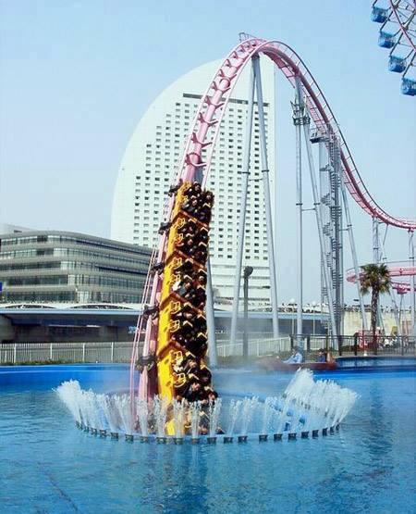

Fair Use For Teaching. Retrieved 6/25/13.
http://iamkoream.com/wp-content/uploads/2011/11/289782460-17135735.jpg

