Target 1258 5202
Water Park, Beijing
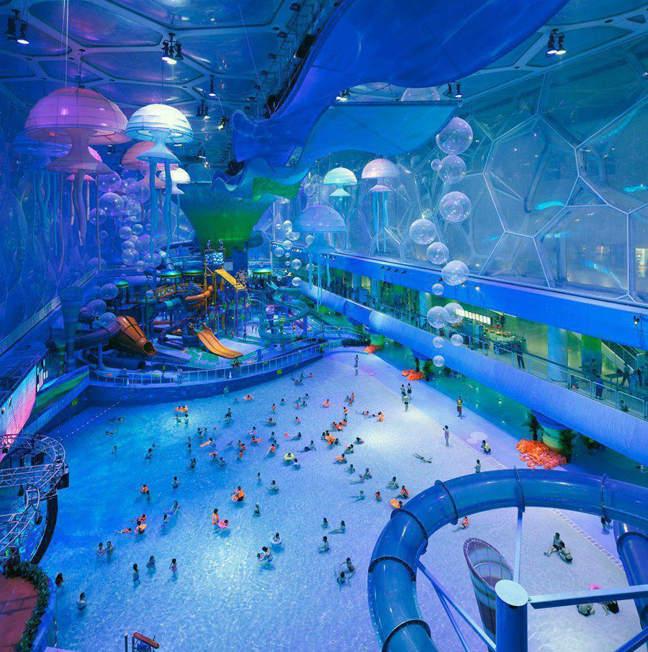

Fair Use For Teaching. Retrieved 6/25/13.
http://urbanpeek.com/2011/08/20/beijings-olympic-pool-transformed-to-a-wacky-water-park/

