Target 0780 3567
USS John C. Stennis, Navy

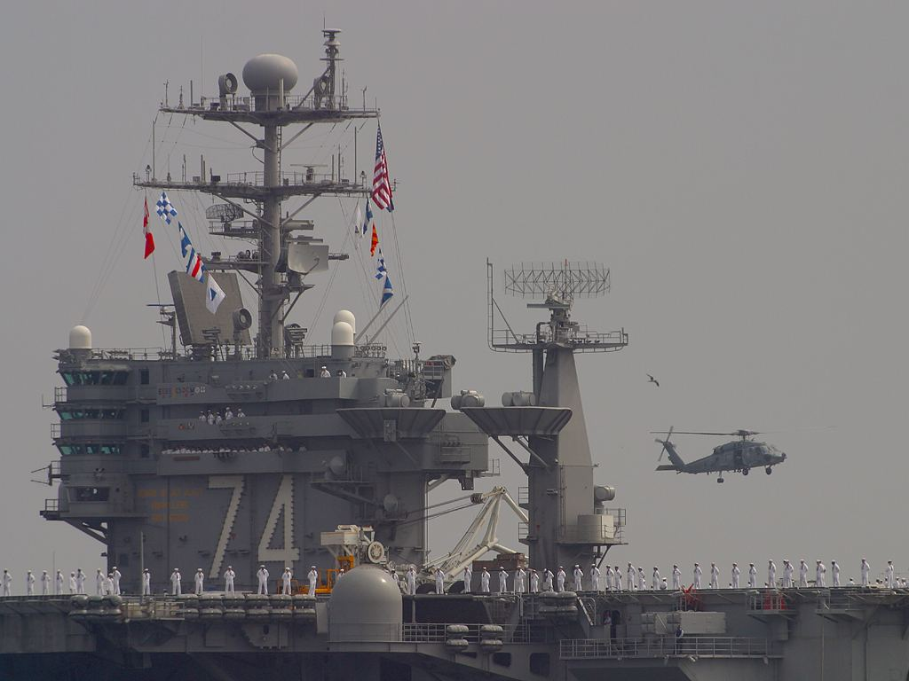

Fair Use For Teaching. Image Purchased from PDPhoto.org.
http://www.pdphoto.org/PictureDetail.php?mat=&pg=5114

